**Bayesian classifier**

It needs the training data set. Therefore, you have to put “data” folder in C drive. So, path would like “C:\\data”.

Here, I have to concatenate two pipelines. Therefore, I have created three OWL files called first pipeline, second pipeline and combine pipeline.

**Two different type of output is generated by the system**

**First type** of output is shown as below. Therefore, you must use the combine pipeline owl file and you will get the result as show below regarding to any selected movie.

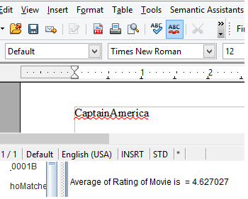

**For generating second type** of output, you have to care about two things. First, you have to replace owl file named “secondpipeline” with the file which is inside the folder name “Owlfile/SecondPipelineTest” and you have to write the tweet in brackets. 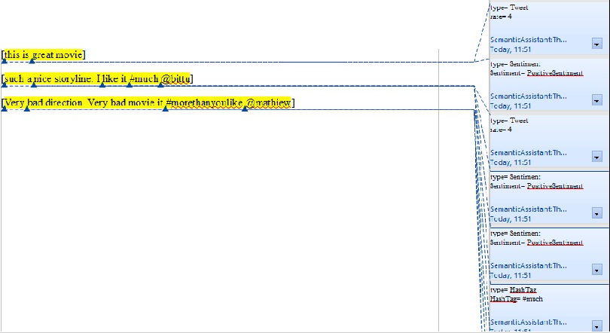

**Gazetteer list**

I am using two gazetteer list called PositiveWord and NegativeWord which are used for sentiment detection. Therefore, put it into list.def file

**Manually annotated document for evaluation**

I saved manually annotated document for evaluation of movie rating system XML format which is stored at “Evaluation\Manual Annotation”. You can run second pipeline with replaced Second pipeline OWL file.

**Cross Fold Evaluation**

For cross fold evaluation, you have to replace the files which are in “Data” with the files which are in “Evaluation\CrossValidation” folder and data folder should be in the path like “C:\\data”. Finally, put the tweets which are in testdata file into open office and run the combined pipeline.